TABLE OF CONTENTS

1 BUSINESS PROBLEM 1

1.1 Problem statement 2

1.2 Targeted audience 2

2 DATA 3

2.1 Data from Wikipedia 3

2.2 Data cleaning 4

2.3 Geographical Location data using Geocoder Package 4

2.4 Determining data through Foursquare API 5

3 REFERENCES 6

# BUSINESS PROBLEM

Globally, the rates of obesity-related chronic diseases have become a public health concern. A modern diet is mainly processed food high in total fat, saturated fat, and simple sugars, which increases the risk of developing obesity [1]. In 2010, over 27 million (approximately 11%) adults were diagnosed with heart disease. Nearly 20 million Americans had cancer as of 2010, while 21 million Americans had diabetes mellitus. Most people are transforming into distinct lifestyles and dietary changes to reduce the high risk of chronic disease caused by modern nutritional patterns. Lately, doctors recommend that patients should live a healthy life and not depend on reactionary medicine. Vegetarianism is the best diet to enhance health. The study of [2] stipulates that vegetarians warranted a reputation of being overall healthier people. They are often associated with living more healthily and mindfully by participating in more regular exercise, avoiding fattening or sugary foods, and avoiding alcohol and smoking. Obesity is linked to lower rates of a vegetarian diet, heart disease, and diabetes mellitus (DiMarino, 2013). Figure 1 illustrates some of the food consumed by vegetarians.



Figure 1: Humankind Ventures Ltd, 2020

## Problem statement

There is a limited number of vegetarian restaurant, therefore, there is an opportunity to create employment through vegetarian businesses. Globally, unemployment is a huge challenge. According to [4] internationally, young people are three times unemployed as compared to adults, and over 350 million young people are not engaged in education, employment, or training. Therefore, there is a need to create employment. This study is significant since segmentation and clustering neighbourhoods’ information provides entrepreneurs with knowledge, for example (entrepreneurs will know their competitors locations and areas where there is a need for their products).

## Targeted audience

The entrepreneurs can use segmentation and clustering neighbourhoods’ information as a prototype when exploring new opportunities to open a thriving Vegetarian restaurant business in Toronto.

The skills gained on the segmentation and clustering neighbourhoods assignment can contribute immensely to the body of knowledge since the study findings can be used as a reference when conducting research. The target audience of the project is academics and non-academic researchers. Academics can use the information to educate learners and enhance the quality education. Tourists can study this kind of assignment to understand the area of interest before visiting Toronto.

# DATA

In this assignment, I explored neighborhoods in Toronto to determine where the entrepreneurs can open a new Vegetarian restaurant. The initial stage of implementing this assignment project was to use the Notebook to build the code to scrape the following Wikipedia page, [https://en.wikipedia.org/wiki/List_of_postal_codes_of_Canada:_M](https://en.wikipedia.org/wiki/List_of_postal_codes_of_Canada:_M.)  I applied the head method to display the columns and rows of the data. I used the BeautifulSoup package for web scraping.

## Data from Wikipedia

The data below was read from Wikipedia into Pandas Dataframe.

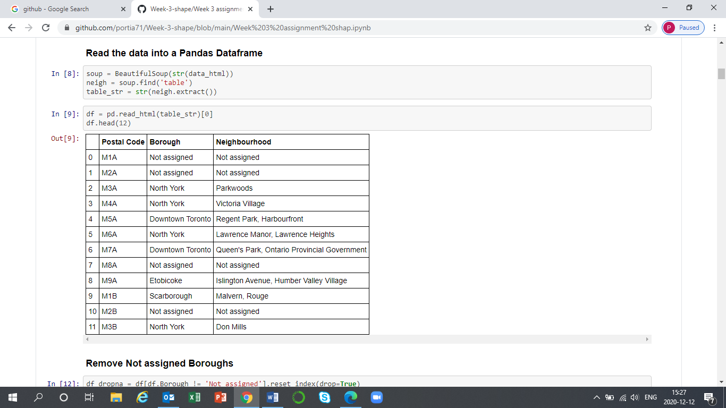

## Data cleaning

Columns that were not relevant dropped using the drop () method. I used the codes illustrated below to clean the data. After that, I processed the cells that have an assigned borough. The dataframe consists of three columns: PostalCode, Borough, and Neighborhood. Then I ignored the cells with a borough that is not assigned.

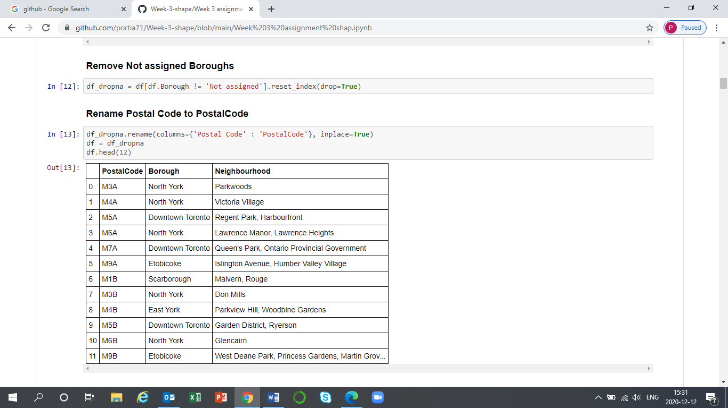

## Geographical Location data using Geocoder Package

I used A Geocoder package to determine the neighborhoods' geographical location and venue data of Vegetarian restaurants. Below is the Geographical location data using the Geocoder.

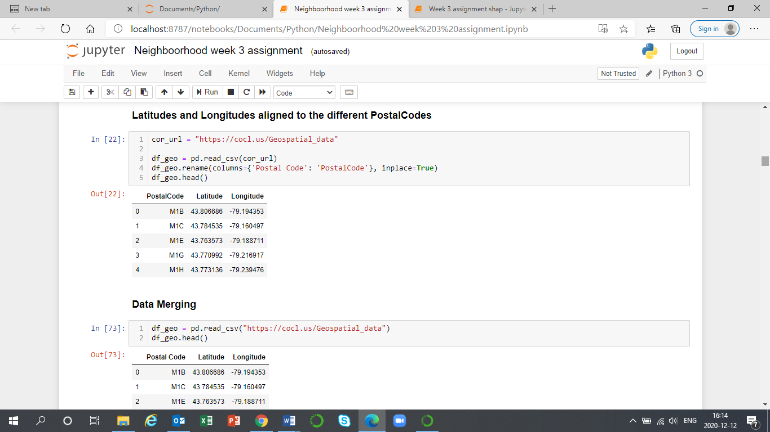

## Determining data through Foursquare API

I used Foursquare to determine various Vegetarian restaurant neighborhood. The Venue data assists in deciding the area, which is best suitable to open a Vegetarian restaurant. Below are the codes for determining the first neighborhood in df_toronto, averaging latitude and longitude values, and the top ten number of venues returned by Foursquare API.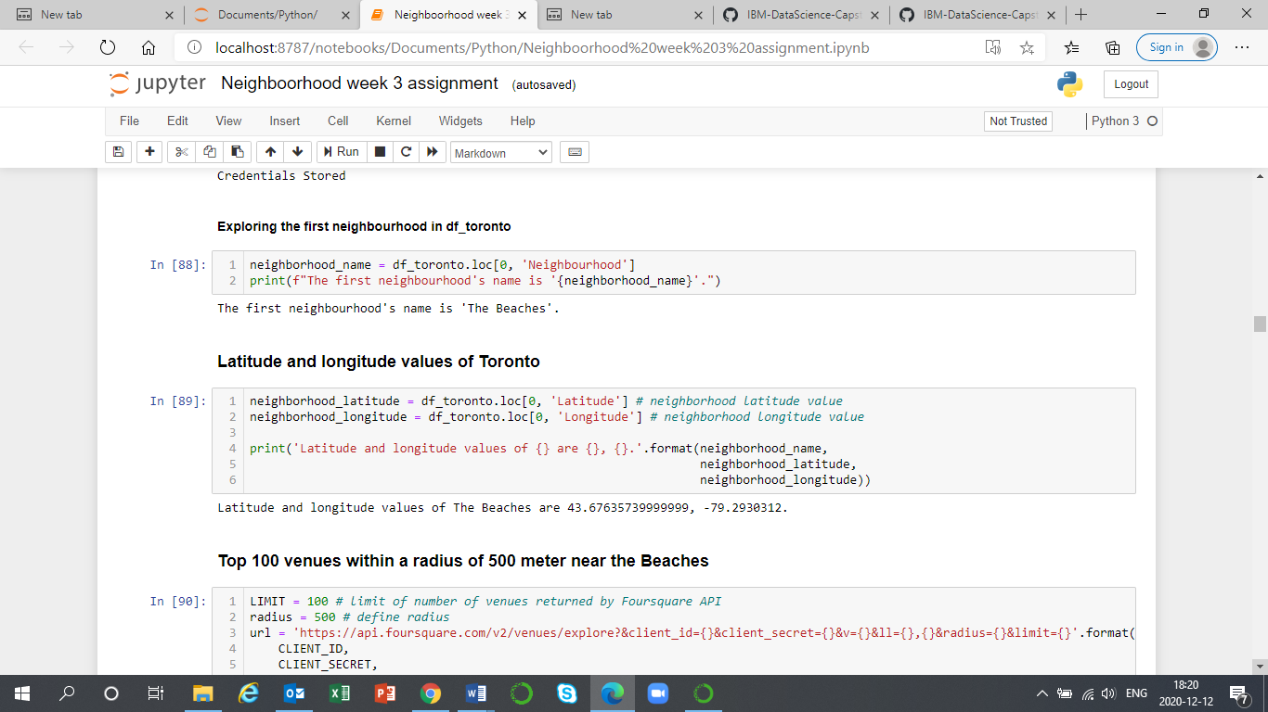

# REFERENCES

1. DiMarino, A., 2013. *A Comparison of Vegetarian Diets and the Standardized Western Diet in Nutrient Adequacy and Weight Status* (Doctoral dissertation, The Ohio State University).
2. Berich, H.M., 2015. Knowledge and Perceptions of Vegetarian Diets Among College-Aged Students.
3. Humankind Ventures Ltd, 2020. How to Avoid Deficiencies on a Vegan Diet? [How to Avoid Deficiencies on a Vegan Diet - Forth Life (forthwithlife.co.uk)](https://www.forthwithlife.co.uk/blog/how-to-avoid-deficiencies-on-a-vegan-diet/)
4. Hanna, A.L., 2014. The Global Youth Unemployment Crisis: Exploring Successful Inifiafives and Partnering with Youths. *Durham, NC: Sanford School of Public Policy, Duke University. Retrieved August*, *14*, p.2018.